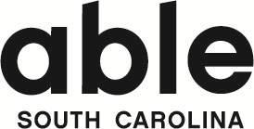

Internship Application
Full Name:
Email:
Phone:
Address:
Education Program:
Program Level: (choose one)
☐ High School ☐ College ☐ Graduate School (Masters or Ph.D.)
Expected graduation date:
Internship start date: End date:
Career Goals:

Why does Able South Carolina seem like a good fit?

How did you hear about us?

